“CAPTIVE NETWORK ATTACK”

It has been two years since Comcast introduced Free wifi hotspots all across the United States. Since its introduction in 2014, it has accumulated over 500,000 different hotspots, often piggybacking off of gateways supplied to average customers. It has advertised its service as secure for use. I would like to offer this white-paper as proof that a mass scale phishing attack could easily be deployed in the following manner:

- Fake wifi hotspots hosted on...
  - Compromised windows machines
  - Linux machines with access to a wifi card
    - Possibly including linux based routers (more research needed)
- Serving…
  - Phishing pages disguised as Comcast login pages
  - Drive by exploit kits, maybe even alongside a phishing page

These are all very serious risks that should not be ignored, especially considering the risks that these types of attacks pose. Before we enter the proof of concept itself, I would like to address the issue of mitm (man in the middle) attacks. Although an mitm attacks are possible, I will not address them here. There are many other papers discussing mitm attacks, it is not necessary to do this here.

General concept:

The general concept behind all of these attacks depends on a hotspot, a miniture dns server, a small web server, and a database.

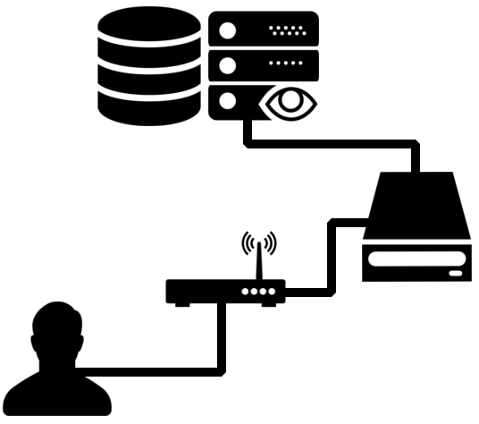

The “Captive Network Attack”:
- The victim logs into a bad wifi router
- The victim makes a DNS query to get to a websites
- The bad dns server gives the user the local address of our phishing/exploit page
- ???
- Profit
Windows Machines:

Ad hoc wifi networks have been a built in feature of windows since Windows XP. Although they are no longer an easily accessible feature with the following command an ad-hoc network can be set up:

netsh wlan set hostednetwork mode=allow ssid=xfinitywifi

And then it can be hosted with the command:

netsh wlan start hostednetwork

Now we need to set the DNS server of the hosted network. First we need to skim the list of current networks on our machine with the command:

netsh interface show interface

After figuring out which network is the hosted network (usually it is named “Hosted Network” or “Hosted Network 1” depending on how many hosted networks the user has used in the past), we have to set the dns server with the command:

interface ip set dns “Hosted Network” static xxx.xxx.x.x

Now the DNS server has been set for the hosted network. The malware must now set up a dummy server, that sends an A record pointing to our server.

NOTES:

You will notice that I did not actually set up access to the internet, I simply set up an ad hoc wifi network. DO NOT SET UP ACTUAL ACCESS TO THE INTERNET. The user should be forced to use our dns server for the redirect to work properly.

Windows machines cannot be connected to wifi while they are broadcasting out a signal unless they have two antennas (a highly unlikely scenario). If this was done on an exploited machine, then the malware would most likely have to wait until the computer is inactive to activate the ad hoc network.
Linux Machines:

Due to the low marketshare of Linux laptops/desktops, I do not think it is necessary to research the process of doing this through the command line (a bit of an irony, considering that the command line has a more central role to most *nix machines). This was last done on an Ubuntu computer with a MATE UX.

First, go to the Network Manager Applet (nm-applet), and hit create a new Wifi Network.

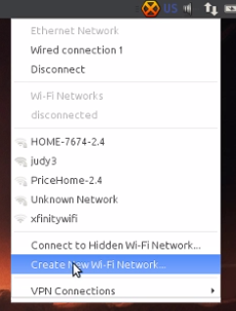

Next, name your wifi connection “xfinitywifi” with no security (note the gray boxes, I already set one up while testing, nm-applet remembers your choices).

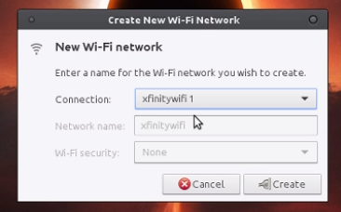

Now right click on nm-applet and hit “Edit Connections...”

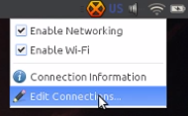

Now click on the name of the adhoc network you just set up (note: it may be xfinitywifi 1 if you have connected to xfinity wifi before):

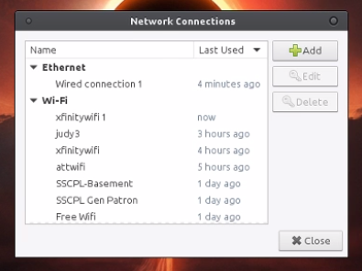

Now, head over to the ipv4 settings tab. Change the method to DHCP, and plug in the address of your DNS server.

